**Consultation: North East England Water Fluoridation Expansion Programme – BASCD Response**

**Q.** **How is your organisation affected by the proposal to expand fluoridation in the north east of England - for example, it is located or does it operate in an area affected by the proposal**? (optional) (maximum 100 words)

The British Association for the Study of Community Dentistry (BASCD) is an alliance of individuals from across the UK including, but not limited to, the area of the proposal with an interest in population oral health.

In 2023, BASCD launched its position statement on community water fluoridation (<https://www.bascd.org/wp-content/uploads/2023/06/Water-Fluoride-Statement-02.06.2023.pdf>). The statement outlines BASCD’s strong support of community water fluoridation as a safe, equitable and effective intervention, which should be implemented on a universal basis to reduce the prevalence and severity of tooth decay and reduce oral health inequalities. [Words: 87]

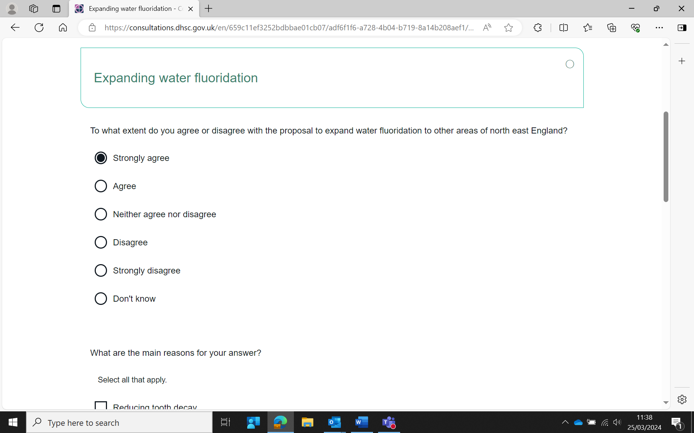**Q. To what extent do you agree or disagree with the proposal to expand water fluoridation to other areas of north east England?**

**Q. What are the main reasons for your answer? (select all that apply)**

* Reducing tooth decay
* Reducing the number of dental treatments such as tooth extractions or fillings
* Reducing oral health inequalities
* Reducing costs to the NHS
* Improving other health outcomes
* Concerns about negative health impacts of water fluoridation
* Concerns about the environment
* Ethical arguments
* Other

**Q. Please explain your answers and provide supporting evidence, including weblinks, you have to support your view** (optional). **If you selected ‘ethical arguments’ please explain these** (maximum 250 words). You may upload a document to support your response (optional)

There have been multiple authoritative evidence reviews from around the world over the last 20 years; the common findings of these are that water fluoridation reduces levels of tooth decay in populations served and that there is no convincing scientific evidence of harm to health other than an increase in the prevalence of mild dental fluorosis.

Health monitoring of the impact of fluoridation schemes in England have repeatedly shown lower levels of dental caries among children in fluoridated areas and a greater impact on those from more deprived areas, with potential to reduce oral health inequalities and reduce the prevalence of severe disease. These studies have shown no indication of greater levels of systemic diseases.

Health monitoring in England has not identified an increase in concern over dental aesthetics in fluoridated areas.

There is no convincing evidence that there are environmental harms from water fluoridation. There may be reduced carbon emissions associated with the avoidance of future dental treatment.

Although water fluoridation does remove choice from individuals, this has to be balanced against the potential loss of benefits to the population, particularly vulnerable groups (e.g., children). The United Nations Convention on the Right of the Child (1989), Article 3, states that ‘…the best interest of the child should be the primary concern, particularly with regard to budget, policy and law makers’. Other aspects of drinking water quality are not subject to individual choice.

**Q. If you have any scientific evidence or evidence on the cost-benefit analysis for us to consider in our final impact assessment, please provide this** (optional) (maximum 250 words). You may upload a document to support your response (optional)

Roberts DJ et al. (2022) The effect of community water fluoridation on dental caries in children and young people in England: an ecological study. 10.1093/pubmed/fdac066

The LOTUS Study: Fluoridation for Adults: <https://sites.manchester.ac.uk/lotus/>

Shen, A., Bernabé, E. and Sabbah, W., (2021) Systematic review of intervention studies aiming at reducing inequality in dental caries among children. [10.3390/ijerph18031300](https://doi.org/10.3390/ijerph18031300)

Public Health England. 2018. Water Fluoridation Health monitoring report for England 2018. https://assets.publishing.service.gov.uk/government/uploads/system/uploads/attachment_data/file/692754/Water_Fluoridation_Health_monitoring_report_for_England_2018_final.pdf

Public Health England. 2022. Water fluoridation Health monitoring report for England 2022. <https://assets.publishing.service.gov.uk/government/uploads/system/uploads/attachment_data/file/1060471/water-fluoridation-health-monitoring-report-2022.pdf>

NHMRC. 2017. Water fluoridation: dental and other human health outcomes. https://www.nhmrc.gov.au/sites/default/files/documents/reports/fluoridation-infopaper.pdf

New Zealand Office of the Prime Minister’s Chief Science Advisor: Fluoride in our drinking water: An update on the evidence: <https://www.pmcsa.ac.nz/2021/06/02/fluoride-in-our-drinking-water-an-update-on-the-evidence/>

Cronin J et al. A cost-effectiveness analysis of community water fluoridation for schoolchildren. [10.1186/s12903-021-01490-7](https://bmcoralhealth.biomedcentral.com/articles/10.1186/s12903-021-01490-7)

Health Research Board: November 2022 (Impact of community water fluoridation on systemic health excluding oral health. An evidence review): <https://www.hrb.ie/publications/publication/impact-of-community-water-fluoridation-on-systemic-health-excluding-oral-health-an-evidence-review/returnPage/1/>

Taher MK et al. Systematic review of epidemiological and toxicological evidence on health effects of fluoride in drinking water. Systematic review of epidemiological and toxicological evidence on health effects of fluoride in drinking water. Crit Rev Toxicol. 2024; 6:1-33 (https://pubmed.ncbi.nlm.nih.gov/38318766/)

Guth S. et al. Toxicity of fluoride: critical evaluation of evidence for human developmental neurotoxicity in epidemiological studies, animal experiments and in vitro analyses. Arch Toxicol. 2020;94:1375-1415. (<https://pubmed.ncbi.nlm.nih.gov/32382957>)

Duane B et al. The environmental impact of community caries prevention- part 3 water fluoridation. [10.1038/s41415-022-4251-5](https://doi.org/10.1038/s41415-022-4251-5)

Any other issues:

**Q. Is there anything else you would like us to consider in this consultation?** (optional) (maximum 250 words). You may upload a document to support your response (optional)

Similar to many other non-communicable diseases (such as obesity), the prevalence of dental decay follows a socio-economic gradient with those living in the most deprived areas suffering from highest levels of tooth decay. A single intervention such as water fluoridation cannot address the whole issue therefore policy makers should consider a universal proportionate approach to oral health improvement that includes, but is not limited to, water fluoridation. Water fluoridation does however have unique advantages in that it does not require dental attendance or behavioural change and so will not potentially widen inequalities.

When planning oral health improvement programmes, it is important for policy makers and commissioners to seek specialist advice and support from dental public health teams.

Documents of relevance:

Nuffield Council on Bioethics: Ethics tools for decision-makers: <https://www.nuffieldbioethics.org/assets/pdfs/Ethics-tools-for-decision-makers-FINAL1.pdf>

Public Health England: Public health ethics in practice: <https://www.gov.uk/government/publications/public-health-ethics-in-practice>

FDI policy statement Water fluoridation - <https://www.fdiworlddental.org/promoting-oral-health-through-water-fluoridation>

FDI policy statement Promoting oral health through fluoride - <https://www.fdiworlddental.org/promoting-oral-health-through-fluoride>

WHO Global Oral Health Action Plan - Strategic objective 2 - Global Target 2.2: Optimal fluoride for population oral health. Action 27: Optimize the use of fluorides for oral health. <https://www.who.int/publications/m/item/draft-global-oral-health-action-plan-(2023-2030)>

World Health Organization. 2020. Ending childhood dental caries: WHO implementation manual. Available at: https://www.who.int/publications/i/item/endingchildhood-dental-caries-who-implementation-manual

D.M. O’Mullane R.J et al. . Fluoride and oral health. 10.1922/CDH_3707O’Mullane31

McGrady, M.G., Ellwood, R.P., Maguire, A., Goodwin, M., Boothman, N. and Pretty, I.A., 2012. The association between social deprivation and the prevalence and severity of dental caries and fluorosis in populations with and without water fluoridation. hdoi.org/10.1186/1471-2458-12-1122